Special Education Process Map
This chart shows how a child gets into a special education program. State law has a timeline for the process. A district must ask a parent for consent for evaluation or send a notice that no tests are needed within 15 business days of receiving a written referral. The evaluation must be done within 60 calendar days of when the school gets parent consent to evaluate or the date the parent was notified that testing is not needed. An IEP and placement must be developed within 30 days of deciding a child is eligible for special education. The evaluation can take more than 60 days, if the parent does not make the child available for testing, or if the child moves to another school district before the evaluation is done. In some cases, and only if parents agree, the evaluation of children being evaluated for specific learning disabilities may be extended more than 60 days.
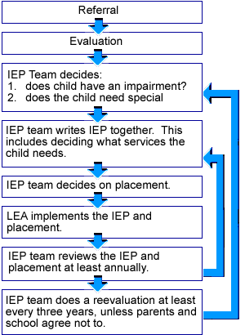
Although this chart shows a series of decisions, all the decisions are connected. All the decisions are centered on the needs of the child.
For example, when the IEP team talks about evaluation, they also think about what services the child will need and where the child will get the services.
For some children, all the IEP team’s decisions can be made in one meeting. For other children, the IEP team will need to meet together more than once.
Anyone on the IEP team can ask for more time if it is needed. Anyone on the IEP team can also ask for an IEP team meeting to be held if there are changes to be talked about.

